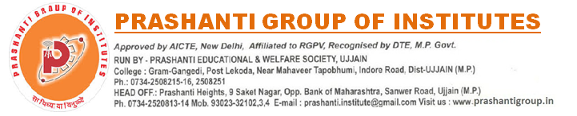

NOTICE CAMPUS DRIVE Date: 6 Dec 2021
Toppr Technologies Pvt. Ltd. 2020 & 2021 Batch

BE/B.Tech / BBA / MBA B.Sc / M.Sc / B.ed / M.ed ( 2020 & 2021 Batch Pass-out)
About :Toppr is looking for a Subject Matter Expert in its Knowledge Team. As a Subject Matter Expert, you’ll clear students' doubts and help them improve their understanding. Manage a team of freelancers to ensure a seamless experience for the students using our platform. Training of freelancers and providing them regular feedback on their doubt solving skills. So, if you are student-centric and driven to change the way we look at education, then we’d love to talk to you!
Requirement : Subject Expertise required will be any of the subjects namely Physics, Chemistry, Maths and Biology upto class 12.
Package: 20,000 INR Per Month
Joining: Immediate
Position : SME (Subject Matter Expert )
Location : Permanent Work from Home

Director
Training, Placement & Development
Prashanti Group of Institutes, Ujjain

